**Week-06**

**DLD LAB-05**

**Karnaugh Map (K-Map) Simplification**

**Objectives:**

* To understand concept of K-Map Simplification.
* To validate implementation of K-Map simplification using Tinker Cad / Circuit Maker.

**Karnaugh-Map (K-MAP)**

Karnaugh Map (K-Map) is a **visual method** used in **Digital Logic Design (DLD)** to **simplify Boolean algebra expressions** and minimize logic gates in circuits.

**Why Use K-Map?**

* Simplifies complex Boolean expressions quickly.
* Reduces the number of logic gates needed.
* Helps in designing efficient digital circuits.

**How K-Map Works?**

1. **Draw a Grid** based on the number of variables:
   * **2 variables → 2x2 grid**
   * **3 variables → 2x4 grid**
   * **4 variables → 4x4 grid**
2. **Fill the Grid** with **1's (True) and 0's (False)** from the truth table.

**Example-01:**

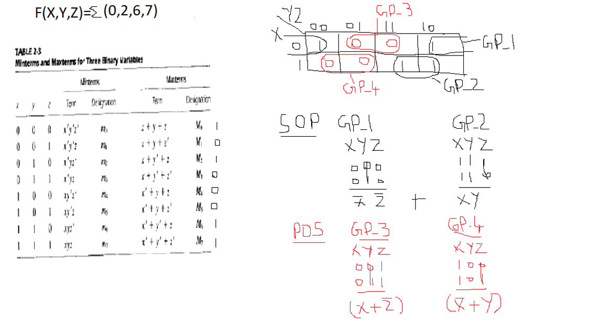

**Example-02:**

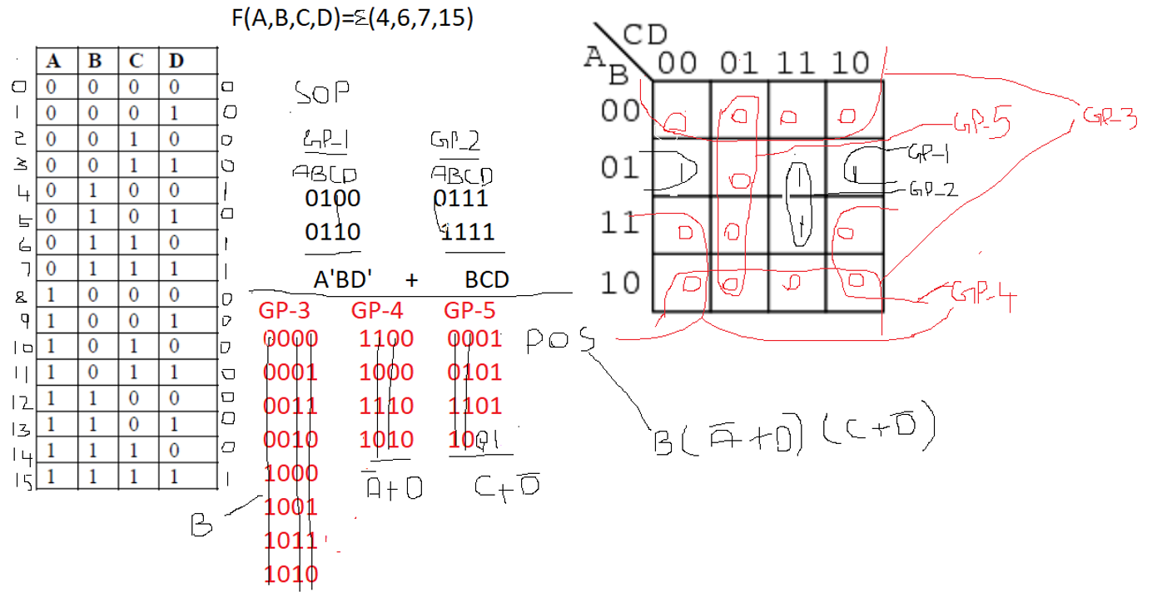

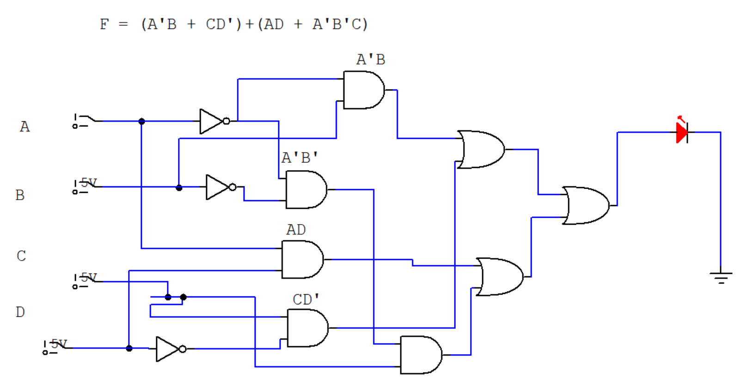

**LAB TASKS**

**TASK-01**

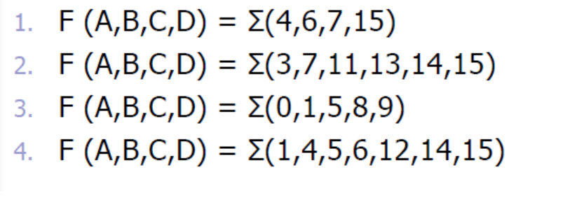

**Solution:**

**TASK-02**

**Min term Expressions (SOP):**

1. F (A, B, C, D) = Σ (1, 3, 7, 9, 11, 14)
2. F (A, B, C) = Σ (0, 2, 5, 6)
3. F (A, B, C, D) = Σ (2, 4, 8, 10, 12, 13, 15)
4. F (A, B, C) = Σ (1, 3, 4, 7)
5. F (A, B, C, D) = Σ (0, 5, 6, 9, 11, 13)

**You have to do the followings:**

* Draw truth tables.
* Simplify using **K-Maps.**
* Derive the final Boolean expression.
* Implement using logic gates on Circuit Maker.

**Solution:**

**TASK-03**

**Maxterm Expressions (POS):**

1. F (A, B, C, D) = Π (0, 2, 5, 8, 10, 13, 15)
2. F (A, B, C) = Π (1, 4, 7)
3. F (A, B, C, D) = Π (1, 3, 6, 9, 11, 12, 14)
4. F (A, B, C) = Π (0, 2, 3, 6)
5. F (A, B, C, D) = Π (4, 5, 7, 10, 11, 13)

**You have to do the followings:**

* Draw truth tables.
* Simplify using **K-Maps.**
* Derive the final Boolean expression.
* Implement using logic gates on Circuit Maker.

**Solution:**